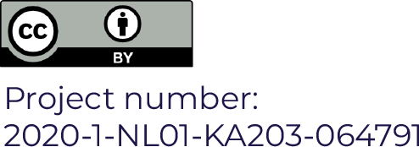
Participant Evaluation
Event:
Date: dd/mm/yyyy
Location (Venue, Country):

Dear Participant,
Thank you for attending the event. You are kindly asked to complete the following questionnaire. We appreciate your valuable contribution, and we thank you in advance.

Please circle the appropriate number on the right side of every statement, so that it depicts your agreement with the statement, where:
1 – strongly disagree; 2 – disagree; 3 – undecided; 4 – agree; 5 – strongly agree
Event content
The content of the event is relevant to the topic | 1 | 2 | 3 | 4 | 5
The discussions were relevant for the participants | 1 | 2 | 3 | 4 | 5
The materials distributed are useful and informative | 1 | 2 | 3 | 4 | 5
The event was interactive and interesting | 1 | 2 | 3 | 4 | 5
The event activities provided me substantial amount of practical information and answers | 1 | 2 | 3 | 4 | 5
The goal of the event has been achieved | 1 | 2 | 3 | 4 | 5
Organization
The overall organization was professional | 1 | 2 | 3 | 4 | 5
The style and level of communication between organizers and participants was professional | 1 | 2 | 3 | 4 | 5
The methods of working were suitable for the topics and for the participants | 1 | 2 | 3 | 4 | 5
The event time management and length were appropriate | 1 | 2 | 3 | 4 | 5
The venue and facilities | 1 | 2 | 3 | 4 | 5
Event results
My expectations about this event were met or exceeded. | 1 | 2 | 3 | 4 | 5
I enjoyed the cooperation and interaction with other participants | 1 | 2 | 3 | 4 | 5
This event covered to a very high extent the topics I have expected | 1 | 2 | 3 | 4 | 5

Event general assessment
How would you generally mark this event?
1 | 2 | 3 |  | 4 |  | 5
Very Poor | Poor | Fair |  | Good |  | Excellent
The information I got will be of immediate use to me |  |  | 1 | 2 | 3 | 4 | 5

